County of San Diego Mental Health Plan

Prior Authorization Day Services Request (DSR)
2022

COMPLETED BY:
- Licensed/Waivered Psychologist
- Licensed/Registered/Waivered Social Worker or Marriage and Family Therapist
- Licensed/Registered Professional Clinical Counselor
- Physician (MD or DO)
- Nurse Practitioner

CO-SIGNATURE:
  - Prior Authorization Day Service Requests must be completed by or co-signed by a Licensed Mental Health Professional
  - Co-signature from Licensed Mental Health Professional indicates they have reviewed and agree with the findings of the request

COMPLETION REQUIREMENTS:
- Prior Authorization Day Services Request form is completed by the Day Services provider and submitted to Optum via FAX (866) 220-4495 for all clients prior to the initial provision of Day Services
- Continuing Prior Authorization Day Services Requests are completed by the Day Services provider and submitted prior to expiration of the initial authorization period (within 90 days for STRTP and 180 days for San Pasqual Academy)
- Continuing Prior Authorization Day Services Requests shall be submitted at least 5 business days prior to the expiration of Day Services Authorization, and can be submitted up to 10 business days prior to the expiration
- Prior authorization shall be obtained before Day Services are initiated. For hybrid programs, Outpatient Services may be provided prior to the authorization of Day Services

DOCUMENTATION STANDARDS:
The following elements of the Prior Authorization Day Services Request form shall be addressed:

Client Information
  - Include Name, Client ID and Date of Birth
  - Include the Placing or Referring agency
  - For STRTPs-Select one of the options for the Qualified Individual Assessment
  - For Out of County clients, the request shall include either:
    - (STRTP only) A copy of the Notice of Presumptive Transfer Form for foster youth placed through AB1299 Presumptive Transfer in a STRTP and a copy of QI Assessment reflecting STRTP level of care determination or
    - A copy of the SAR for youth placed through AAP/KinGAP. For youth in a STRTP the request shall include written COR approval, obtained by emailing the COR, to serve youth under the County contract due to planned discharge to a San Diego residence.

Day Program Information
  - Include Legal Entity, Program Name, Phone number, Fax number, Unit number, and Day Services Program Subunit number

Scope, Amount and Duration of Day Services Request
  - Identify the scope and duration of Day Services to be provided (STRTP – 90 days, or SPA – 180 days).
  - Include the amount of services requested (select Up to 5 Days Per Week or Up to 6 Days Per Week) which shall not exceed the Day Program schedule that has been approved by BHS QM

2022

Medical Necessity Criteria for Day Services
  - Diagnosis - Provide the name of the DSM/ICD Mental Health diagnoses that are the focus of mental health treatment

Medical Necessity Criteria
- Select and explain how client meets medical necessity. (Must meet either A or B and C):
  - Client has a condition placing them at risk for a mental health disorder due to trauma. At least one of the below.
    - Scoring in the high-risk range under a trauma screening tool
    - Involvement in the child welfare system
    - Juvenile Justice Involvement
    - Experiencing homelessness
OR
  - Client has at least one of the following:
    - A significant impairment or reasonable probability of significant deterioration in an important area of life functioning
    - A reasonable probability of not progressing developmentally as appropriate
    - A need for specialty mental health services, regardless of presence of impairment, that are not included within the mental health benefits that a Medi-Cal managed care plan is required to provide.
AND
  - The client’s condition is due to one of the following:
    - A diagnosed mental health disorder, according to the criteria of the current editions of the DSM and the ICD-10 classifications
    - A suspected mental health disorder that has not yet been diagnosis
    - Significant trauma placing the beneficiary at risk of a future mental health condition
  - Day Services Necessity Criteria: Set by the Mental Health Plan (MHP) per DMH Letter No. 02-01
- Describe client’s needs for Day Services in order to move from a higher level of care to a lower level of care, or to prevent deterioration and admission to a higher level of care
- For continuing service requests only – Describe progress made towards treatment goals during the current authorization period, and/or explain how progress is expected to be made towards treatment goals during the next authorization cycle

Ancillary Services Request (Internal)
  - STRTPs and SPA must complete the Ancillary Request section for the STRTP or SPA to provide Day Services and Outpatient Specialty Mental Health Services (SMHS) during the course of treatment
  - If youth at SPA are receiving Day Services, in addition to Day Services SPA shall only provide the Outpatient SMHS of Intensive Care Coordination (ICC) for the purpose of a Child and Family Team (CFT) meeting outside of Day Service hours
  - STRTP hybrid Day Service and Outpatient programs shall only provide select Outpatient SMHS outside of scheduled Day Service hours, or during scheduled Day Service hours if the youth is unable to attend the Day Program that day
The following Outpatient SMHS are never allowed to be claimed on the same day that Day Services have been claimed:
    - Collateral
    - Case Management
Additionally, the following SMHS are never allowed to be claimed as Outpatient Services at any
2022

time while a client is enrolled in Day Services, as they are bundled with Day Services
    - Assessment
    - Client Plan
  - For Outpatient SMHS that are provided on the same day as Day Services, the provider must document rationale for ancillary Outpatient SMHS, inclusive of:
- Reason why; requested service(s) is not available during day program hours
- Reason why; continuity or transition issues make these services necessary for a limited time
- Reason why; these concurrent services are essential for coordination of care
  - Provide the Day Program Outpatient Subunit number
- Select the amount of Outpatient SMHS requested per day (up to 8 hours)
- Select and describe at least one reason Outpatient SMHS are medically necessary in addition to Day Services
  - Note; if the client is receiving ancillary SMHS from another program or provider, the Day Services Provider shall coordinate with the separate Outpatient Provider to complete a stand-alone Ancillary SMHS Request Form
- Clinical Review Report: Required by the Interim Mental Health Program Approval for STRTPs; Section 13 titled “Clinical Review Report and Transition Determination”
  - Clinical Review Report section is completed for STRTPs requesting continued Day Services. SPA which is not an STRTP, shall therefore always leave this section blank. STRTPs shall also leave this section blank on the initial Prior Authorization Day Services Request
- Describe the type and frequency of services provided during the previous 90-day authorization period for both Day Services and Outpatient Services
- Describe the impact of services toward the achievement of Client Plan Goals and include goals of transitioning to lower level of care
- The Clinical Review Recommendation shall be discussed in a CFT meeting or Treatment team meeting that includes the Head of Service or a Licensed Mental Health Clinician at minimum every 90 days
- Provide the date of the most recent CFT meeting or Treatment Team meeting where the Clinical Review Recommendation was discussed
- Provide a Clinical Review Recommendation for: Continued Treatment in the STRTP,
Transition from the STRTP, or Other
  - If Transition is selected, describe the recommendation for transition
  - If Other is selected, describe the treatment recommendation
  - The Clinical Review Report shall be reviewed for completion by Optum upon submittal
  - The Clinical Review Report shall be reviewed by the BHS Continuum of Care Reform (CCR) team, who will follow up directly with the program when indicated
  - Recommendation for transition or continued treatment must be supported in the client record and CFT documentation

Signature(s)
  - Must include the printed/typed name, credentials, signature and date of the Program Clinician completing the request
  - Must include the printed/typed name, credentials, signature and date of a Licensed Mental Health Professional if the Program Clinician completing the request is not a Licensed Mental Health Professional

2022

OPTUM AUTHORIZATION SECTION
- The following sections are completed by Optum upon receipt from the Day Services provider
- Optum will review and retain the Prior Authorization Day Services Request (DSR) form
- Within 5 business days of Optum receiving the DSR, authorization(s) will be viewable in the CCBH Clinician Home Page Authorizations Tab

Day Services Prior Authorization Determination
  - When the scope, amount and duration of services are authorized, the start date and end date shall be viewable to the requesting provider in the CCBH Clinician Home Page Authorizations Tab. Day Services authorizations will be indicated as “Medi-Cal/DT” with the legal entity name in the “Benefit Plan” column (see image below)
  - When the Prior Authorization Day Service Request is denied, modified, reduced, terminated, or suspended a NOABD shall be issued by Optum to the Medi-Cal beneficiary and requesting provider

Ancillary Services Determination (Internal)
  - When the Internal Ancillary Outpatient Services are authorized, the start date and end date shall be viewable to the requesting provider in the CCBH Clinician Home Page Authorizations Tab. Internal Ancillary Services will be indicated by an “AI” next to the authorization number in the “Authorization #” column (see image below)
  - When the Prior Authorization Day Service Request is denied, modified, reduced, terminated, or suspended a NOABD shall be issued by Optum to the Medi-Cal beneficiary and requesting Day Service provider
- Clinical Review Report Determination (completed by STRTPs only)
  - For STRTP providers Optum shall review the Clinical Review Report for completion. If incomplete,
Optum shall send notification to the requesting provider to resubmit with required data elements
  - Optum shall send the completed Clinical Review report to the BHS CCR team for review
  - The BHS CCR team shall follow up with the STRTP regarding the Clinical Review Report when indicated

Ancillary Services Determination (External)
  - When an ancillary Specialty Mental Health Provider (SMHP) begins treatment, a stand-alone “Ancillary SMHS Request” form must be submitted to Optum by the Day Service provider to request ancillary SMHS from a separate program/provider in addition to Day Services
  - When external ancillary services are authorized, the start date and end date shall be viewable to the requesting provider and the ancillary SMHP in the CCBH Clinician Home Page Authorizations Tab. External ancillary services will be indicated by an “AE” next to the authorization number in the “Authorization #” column (see image below)
  - When the External Ancillary Services Request is denied, modified, reduced, terminated, or suspended a NOABD shall be issued by Optum to the Medi-Cal beneficiary and the requesting Day Service Provider, who shall communicate with the ancillary SMHP within 3 business days
  - See “Ancillary SMHS Request” form and explanation form for additional information

2019

CCBH Clinician Home Page Authorizations Tab:
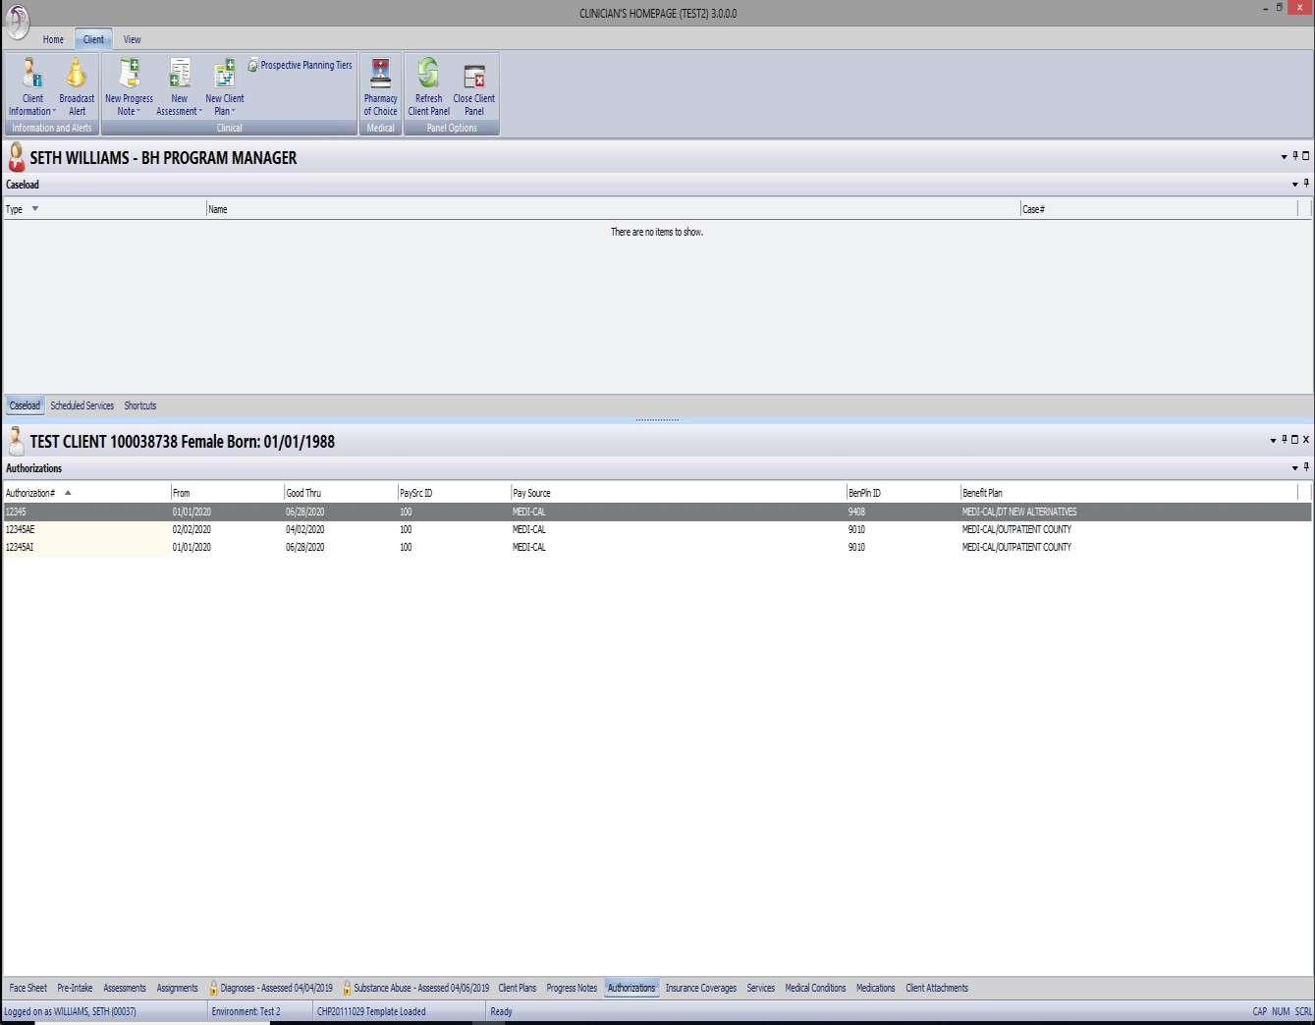

Note: The Prior Authorization Day Services Request (DSR) form replaces the Intensive Services Request (ISR) form effective 1/1/2020
References: DHCS MHSUDS INFORMATION NOTICE NO.: 19-026 Dated 5/31/19: Authorization of Specialty Mental Health Services
DMH LETTER NO.: 02-01 Dated 4/16/2002: Clarification Regarding Medi-Cal Reimbursement for Day Treatment for Children and Youth in Group Home Programs
DMH INFORMATION NOTICE NO.: 02-06 Dated 10/1/02: Changes in Medi-Cal Requirements for Day Treatment Intensive and Day Rehabilitation
DHCS MHSUDS Information Notice No.: 17-016 Dated May 5, 2017; Statewide Criteria for Interim Mental Health Program Approval for STRTP and Enclosure 1 – Interim Mental Health Program Approval for STRTPs

